Assessment of Student Learning at Heartland Community College
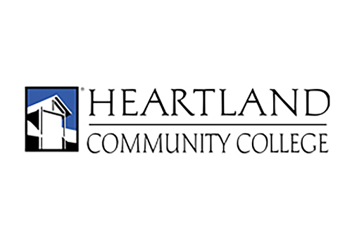
Table of Contents
1. Role of the Assessment Committee 1
2. Purpose of Assessment 2
3. Defining Assessment 3
4. Assessing Student Learning 4
4.1 Essential Competencies 6
4.2 Program Outcomes 7
4.3 Course Outcomes 8
5. References 9

1. Role of the Assessment Committee
The Assessment Committee (AC) is committed to improving student learning and instruction by communicating the importance of assessment and disseminating information related to the provision of resources, guidance, training, and feedback to faculty, administrators, and coordinators regarding learning outcomes and assessment practices for courses, programs, and the essential competencies. Members of the AC are faculty and administrators representing all academic divisions, as well as Academic Affairs, Enrollment and Student Support Services, and Adult Education.
The AC disseminates information related to assessment and, in collaboration with other campus entities, facilitates the thoughtful reflection of assessment practices as related to student learning. In particular, the AC works closely with the Curriculum and Academic Standards (CAS) committee on syllabus and program review processes. At times, the AC also works closely with the college’s Promotion Evaluation and Review Team (PERT) in developing processes for faculty to reflect on their methods of assessment as a means of growth throughout their careers.
The Assessment Committee (AC) dedicates much of its time to examining learning outcomes as well as the means to assess those outcomes. Learning outcomes consist of the College’s Essential Competencies, Program Outcomes, and course learning outcomes. Regardless of scope, the learning outcomes represent the minimum sets of skills or abilities that a student must demonstrate. A variety of methods including Classroom Assessment Techniques (CATs), projects, portfolios, core test items (using a variety of types of question types), papers, presentations, demonstrations, and rubrics are then used by faculty to see how well students demonstrate mastery of the course learning outcomes.

2. Purpose of Assessment
There are essentially three main purposes for assessment. First, assessment is a learning-centered endeavor. Assessment methods can provide the means to improve the learning experience. The goal of faculty should be to help learners be more effective and efficient in the learning process. In the past, some faculty assumed learning was taking place because they were teaching. A standard for many teachers was to give four exams - one roughly every four weeks in a sixteen-week semester - and nothing else. Unless students asked questions, the assumption was made that the students were learning. Then, when an exam was given, those teachers were often surprised by a lack of student performance. Faculty are now much more in tune with what their students are or are not comprehending during the learning process and can adjust their instructional methods before assessing student work. Using an ongoing process of assessment and reflection, many faculty have adopted a variety of teaching strategies (i.e., Universal Design for Learning, active learning techniques, project-based assessment, service learning, authentic assessments, etc.) to better address the diverse learning needs of their students. In this way, assessment can be used to improve the quality of the learning in our courses.
Second, assessment provides faculty with feedback about their instructional practices. Data generated from classroom assessment can lead to valuable insight for instructors about their instructional practices. Assessment is a valuable tool to determine why students are struggling with course material. When faculty know what is successful in the classroom, they can build on what works in class and continually modify their instruction to provide better learning opportunities for students. This makes assessment a formative tool for instructors as well, by giving them valuable data to better plan instruction, implement ideas for instruction, and be better informed to respond in a variety of ways to student learning needs.
Finally, assessment is a requirement for accreditation. For us, accreditation is awarded by the Higher Learning Commission (HLC), and strong assessment practices are integral to ensuring that the College is accredited and that courses can transfer. At the state level, the Illinois Community College Board (ICCB) expects member institutions to demonstrate student learning through an assessment plan.
Assessment is ongoing and integrated to help ensure quality of instruction on the institutional and instructor levels as well as to support student learning.
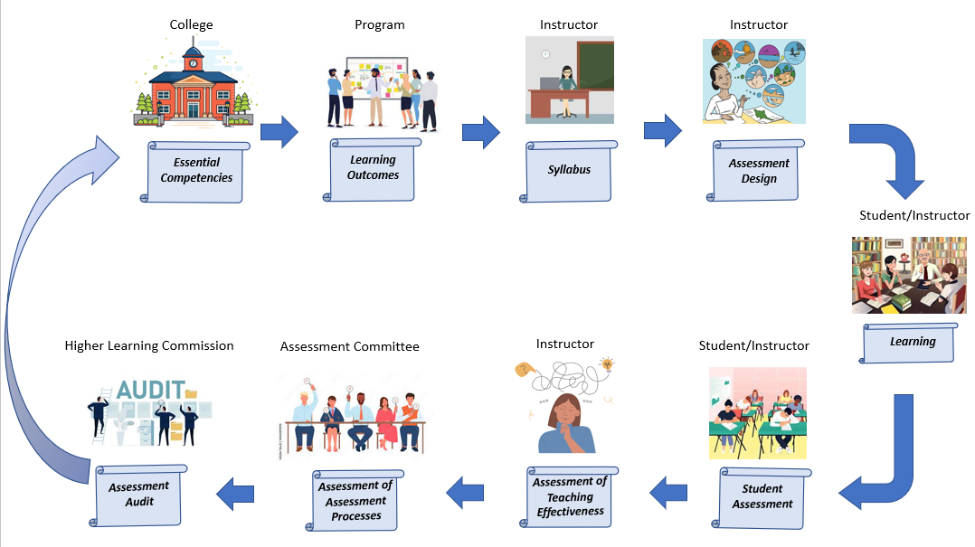

3. Defining Assessment
Assessment involves the collection and analysis of data, numerical or otherwise, to make inferences about student learning, teaching, curriculum, programs, and more. Assessment is often part of an ongoing process that involves decision-making and feedback – both for the student and the instructor. The data from an assessment can be used to make an evaluation. Assessment of learning includes evaluations that may lead to decisions that are designed to improve student learning, instruction, and curriculum.
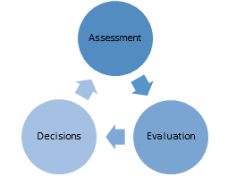

In the classroom, assessment generally involves gathering information about teaching and learning. Assessment can occur before, during, or after a formal meeting time. Assessment allows instructors to measure student achievement and evaluate the effectiveness of their teaching methods. Assessment can and should be both formative and summative in the classroom.
Formative assessments are typically “low stakes” assessments that are built into the learning process and may or may not be associated with points or grades. Formative assessments are typically used to provide feedback to students regarding areas that need further improvements, about their levels of understanding or skill sets so that they can better address learning needs and are more related to assessment as learning. The most common type of formative assessment involves using a Classroom Assessment Technique (CAT) suggested by Cross and Angelo (1993). For example, many faculty members choose to use a one-minute paper, a quiz, a worksheet, or a background knowledge probe to provide feedback before administering a summative assessment.
Summative assessments are those that examine student work at a specific time after learning has been completed (i.e., at the end of a unit, at midterm, at the end of a course or at the end of a program). Examples of summative assessment include a test, a research paper, a performance, a project, a presentation, or a portfolio of work.

4. Assessing Student Learning
In continuing to support a culture of assessment at Heartland Community College, review of assessment practices is part of the College’s continuous improvement process and has been ongoing since its inception. Assessment processes continue to not only include a variety of faculty, staff and administrators but the College is also dedicated to providing a variety of professional development and training opportunities, streamlining processes for collecting and understanding assessment data as well as to better communicate these important aspects related to student learning and success to the campus as a whole.
Exactly what instructors assess depends on the course being taught and the course’s place in a program sequence. In most courses, there is a certain amount of factual information that is important for students to learn, but knowledge of facts is not the only goal we have for students. All courses at Heartland have a Master Syllabus that contains a list of learning goals, which we refer to as learning outcomes. The learning outcomes detail the cognitive and behavioral skills associated with the course content that students are expected to achieve in order to pass the course. These skills are based on a variety of learning verbs, following Bloom’s Taxonomy, to support and engage students toward enduring understanding and to support transfer of learning and better understanding. Accordingly, the college utilizes three methods to assess student learning: the Essential Competencies, Program Outcomes, and Course Learning Outcomes.
Heartland has outlined a set of Essential Competencies (EC’s), the five essential thinking and communication skills expected of all students. They represent the skills and qualities that employers are seeking in graduates and the skills and qualities that help students function in their everyday lives. While not all students completing coursework at HCC will go on to earn an associate's degree, HCC recognizes its obligation to ensure that students are being exposed to and assessed on these competencies in all their college-level courses. In order to ensure broad exposure to the ECs, these five competencies are mapped to course and program level outcomes as appropriate. The ECs represent the College’s attempt to answer the following questions:
- What do we want our learners to be able to do?
- In what contexts will we teach them how to do these things?
Program level outcomes are not used in all areas across campus. Program level outcomes are typically found in Allied Health and Career and Technical Education (CTE) courses and represent broad outcomes that are unique and specific to learning outcomes within a program. These program level outcomes may be influenced by external certification or accreditation bodies. Program level outcomes are typically addressed over multiple courses and are typically broader than course level learning outcomes.
Course learning outcomes are the specific learning goals for a course and are what students will be able to do when they successfully complete the course. The course learning outcomes are created by the course developer, often in collaboration with other instructors who teach the same course and are measurable and achievable statements. Most commonly, Bloom’s Taxonomy serves as a guide for the creation of these statements. However, in some courses, established criteria from a certification or accreditation body outside the college strongly influences the choices in the learning outcomes.
The course learning outcomes represent the minimum to be assessed by all instructors teaching the course. Instructors have the freedom to assess additional skills and knowledge that are not included in the course outcomes so long as they are appropriate to course description and intent.
All outcomes are presented in the course syllabus and given to students early in the course.
Course Outcomes | Essential Competencies
Predict outcomes of physiological parameters when controlled conditions are changed. | PS/CT
Analyze and summarize two journal articles written for health professionals. | C
Apply problem solving skills in predicting probable diagnoses based on symptoms and signs through such activities as case studies and laboratory exercises. | PS/CT

4.1 Essential Competencies
The current structure for the Essential Competencies (EC) includes five goal areas defined according to individual outcomes. Each competency is then assessed by the instructor with a common set of performance indicators. Each course must identify at least two EC’s that it addresses in the course, and the identified EC must be evaluated at least once over the course of the semester. Instructors are free to measure the outcomes across multiple assignments or multiple attempts. Direct links between each course outcomes and an associated EC’s are conducted at least every five years through the Program Review process (which includes reviews by Assessment Committee members) and through course revisions regularly reviewed by the Curriculum and Academic Standards Committee.
The five EC’s and their outcomes are listed below.
- Communication (C) – Students communicate effectively.
  - Students develop an effective message.
  - Students effectively deliver the message.

- Problem Solving Critical Thinking (PS/CT) – Students think critically to solve problems or explore issues.
  - Students think critically to explore an idea.
  - Students explain problem.
  - Students propose a solution to problem.
  - Students implement solution to problem.
  - Students critically evaluate outcomes or ideas.

- Diversity (D) – Students appreciate diversity.
  - Students recognize their own attitudes and/or values.
  - Students recognize attitudes and/or values of others.
  - Students demonstrate respect for other individual’s identities.

- Technology (T) – Students appropriately utilize technology.
  - Students identify available technology.
  - Students select suitable technology.
  - Students utilize chosen technology.

- Social Responsibility (SR) – Students cultivate social responsibility.
  - Students demonstrate self-awareness in connection with social responsibility.
  - Students recognize societal issues.
  - Students develop skills for socially responsible engagement.
  - Students reflect on their engagement with social responsibility.

4.2 Program Outcomes
If a course is part of a specified program of study, they will identify the program level student learning outcomes that the course addresses within the sequence. Often, these programs are influenced by external certification or accreditation bodies in addition to internal program pathways created for student matriculation.
If the program operates under an external requirement, then the given competencies stipulated by state or national boards are added to the Master Course Syllabus as course-level student learning outcomes. For instance, Physical Therapy Assistant program requires that students “Demonstrate effective verbal, non-verbal and written communication with patients, family members, the physical therapist and other healthcare providers in a manner that exemplifies respect for and appreciation of difference” whereas Building Maintenance program requires that students “Understand and safely perform basic building maintenance installation, troubleshooting, and repair including carpentry, plumbing, electrical, appliance repair, and building mechanicals.”
Otherwise, internal program pathway outcomes are provided and are typically addressed over multiple courses and are typically broader than course level learning outcomes. For example, the Global Studies program requires that students “Demonstrates knowledge of other cultures including beliefs, values, perspectives, practices, and products” whereas the History program requires that students “Formulate historical interpretations, both in discussion and in writing, and defend them critically with reference to primary and secondary sources”
These Program Outcomes are assessed during every Program Review, at least, and should be reviewed and revised after any significant curriculum changes.

4.3 Course Outcomes
Each course must have identified course-level learning outcomes for students which represent the skills and thinking qualities expected of students who pass the class. A student’s final grade in the course reflects, in part, the degree to which the learning outcomes were achieved.
Each outcome completes the statement “after successfully completing the course, students should be able to …” These course learning outcomes are consistent across all sections of a course and across all instructors teaching the course, which provides a measure of consistency for students and ensures that the given class transfers and articulates across colleges and universities.
For example, Psychology 220 Personality requires that students “Analyze and apply various personality assessment techniques,” whereas Art 102 Two-Dimensional Design requires that students “Utilize basic studio tools with proficiency, including: computer/digital editing software, and media. Create a portfolio of professional well-crafted design work in both digital and hard copy.”

5. References
Angelo, T. A., & Cross, K. P. (1993). Classroom assessment techniques: A handbook for college
teachers. San Francisco: Jossey-Bass Publishers

